The social cost of carbon (SC-CO₂) has previously been called “the most important number you’ve never heard of.” It may have recently lost this mantle, for the wrong reasons.
On 5 May 2025, the White House released a short memo with outsized consequences. It instructed federal agencies to stop using the SC-CO₂ when designing climate regulations, except in rare cases where courts explicitly require it.
In effect, the decision reduced the value of cutting a tonne of CO₂ to zero in most regulatory analyses, based on the view that quantifying these impacts is too uncertain and would “simply mislead the American public.”
It marks a striking reversal. For more than a decade, United States climate rules on vehicles, power plants, factories, and industrial emissions relied on SC-CO₂ estimates that originated from a 2008 court ruling determining that the value of cutting carbon emissions was "certainly not zero."
Under the Biden administration, the SC-CO₂ estimate was increased to $190 per tonne. Now, the Trump administration has simply stopped counting the damages from climate change altogether. But while doing so may be politically convenient, no one can make those damages disappear.
How did such a central number in climate policy rise to prominence and then fall so swiftly? The answer begins with the models that created it.

A Good Idea: The Pigouvian Elegance of the Social Cost of Carbon
Climate change is a classic negative externality: the costs of emitting CO₂ - heatwaves, floods, lost agricultural productivity, sea-level rise - are borne by society, not only by the emitter. In an unregulated market, this leads to inefficiently high emissions.
Economists formulate this by distinguishing between the marginal private cost of emitting (the cost faced by the polluter) lies below the marginal social cost (the total cost to society). As the private cost excludes environmental damages, it sits below the social cost. The gap between them is the SC-CO₂: the marginal economic damage caused by emitting one additional tonne of CO₂.
This makes the SC-CO₂ conceptually elegant: it directly identifies the optimal carbon price or tax that would internalise this externality and align private incentives with social welfare.

The Pigouvian logic follows naturally: set a carbon tax equal to the SC-CO₂ and the market will internalise the externality. Emissions will fall until the marginal private benefit of emitting is no longer outweighed by the marginal social cost.
This conceptual clarity explains why economists championed the SC-CO₂. For a time, policymakers did too. But calculating the SC-CO₂ requires more than economic theory alone: a model capable of linking the economy, the carbon cycle, and the climate system.

Where IAMs Came From: The Models Behind the SC-CO₂
Calculating the SC-CO₂ requires estimating the long-term effects of climate change on the economy. Enter the Integrated Assessment Model (IAM): a tool that combines insights from macroeconomics and climate science to understand how the economy drives climate change and how climate change, in turn, affects the economy.
The first IAM was introduced in 1975 by William Nordhaus, who was later awarded the 2018 Nobel Prize in Economics for “integrating climate change into long-run macroeconomic analysis.” Since then, IAMs have become the workhorses behind many of the numbers that shape climate debates, most notably the SC-CO₂.
At its core, an IAM is a macroeconomic framework that links human activity and the natural environment. It’s a simplified representation of how the economy and the climate interact, capturing feedback in both directions: how production and energy use drive emissions, and how climate change, in turn, affects the economy. Unlike tools that study just one part of the system - say, an energy-market model or a climate simulation - IAMs integrate these dynamics within a unified framework.
They typically include three interlinked building blocks that form a feedback loop between the economy, the carbon system, and the climate system:
- Economy: A macroeconomic growth model, often neoclassical, that maximises the welfare of a representative agent while accounting for policies such as carbon taxes or renewables subsidies. Economic activity requires energy and therefore generates greenhouse gas emissions that enter the carbon system.
- Carbon System: How emissions from the economy accumulate in the atmosphere and oceans, determining the concentration of greenhouse gases over time.
- Climate System: How the Earth’s system reacts to those greenhouse gas concentrations, determining temperature increases, sea-level rise, and other physical impacts.
A so-called damage function, which represents how impacts from the climate system harm the economy, then completes the feedback loop. Damage functions, however, are devilish to estimate and often omit key impacts, a point we return to later.
These interlinked building blocks are summarised in the figure below. For all their differences, these models provided the machinery that allowed governments to estimate the SC-CO₂ for the first time.
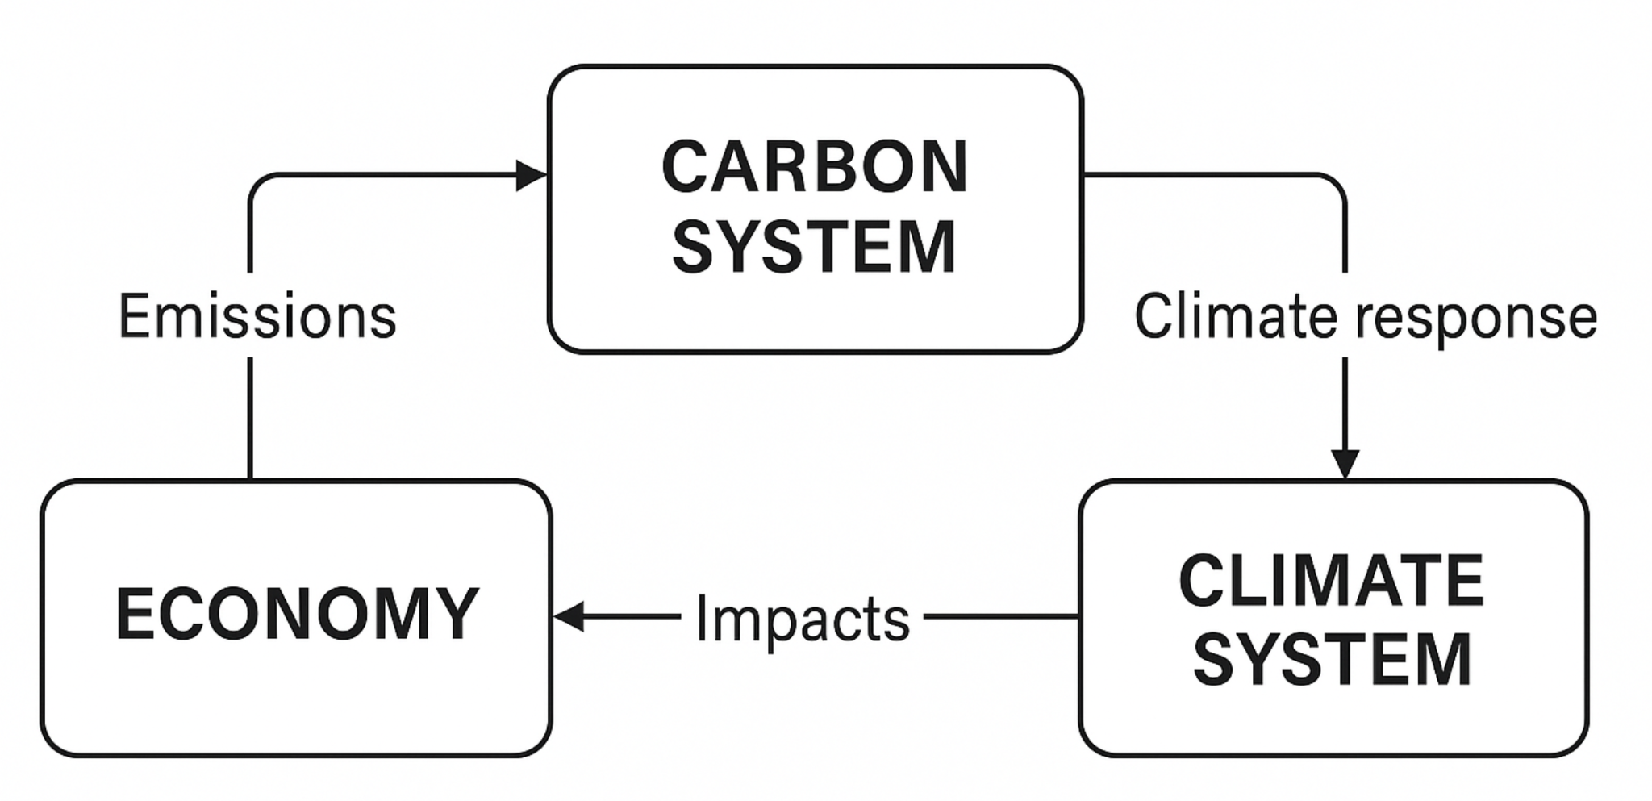

The High-Water Mark: When the SC-CO₂ Shaped Policy
For a period, IAM-based SC-CO₂ estimates reached the centre of climate policymaking, especially in the United States. During the Obama Administration (2009–2017), a government-wide Interagency Working Group (IWG) was established to calculate the SC-CO₂ using three IAMs: DICE, FUND, and PAGE. It yielded a central estimate of around $42/tCO₂.
The SC-CO₂ guided cost–benefit analysis across federal agencies, influencing regulations on vehicles, power plants, and industrial emissions. For a moment, it looked like the future of climate policy evaluation.
This period also demonstrated more broadly why IAMs matter in climate policy. IAMs connect today’s decisions with tomorrow’s economic and environmental outcomes. They are used in three broad ways:
- Policy design: IAMs estimate the SC-CO₂ and simulate the impacts of policies such as carbon taxes or renewables subsidies, allowing the comparison of options.
- Target setting: IAM scenarios translate carbon budgets—defined by climate science—into feasible economic pathways.
- Trade-offs: IAMs help identify which policies minimise overall costs and how benefits are distributed over time.
These capabilities are precisely why IAMs became indispensable during the high-water mark of the SC-CO₂: they offered policymakers a unified way to explore the consequences of climate choices, linking physical climate science with economic analysis in a way no other tool could.

The European Exit: How Carbon Budgets Replaced the SC-CO₂
While the SC-CO₂ was being embedded in United States regulatory practice, Europe and the United Kingdom were moving in a different direction. Instead of relying on IAMs to compute an optimal emissions pathway, the European Union started with political commitments - temperature goals and associated carbon budgets - and then built policy packages and carbon prices consistent with those commitments.
A carbon budget is the total cumulative amount of CO₂ that can be emitted while keeping global warming below a specific temperature limit (for example, 1.5°C or 2°C). Carbon budgets are derived from climate science and used to define the physical limits within which emissions pathways must fit.
Unlike the SC-CO₂, carbon budgets are normative rather than derived: the target temperature is chosen outside the model, and the budget follows from that choice rather than from an economic optimisation. The European Union and the United Kingdom adopted carbon budgets as the primary basis for setting long-term climate targets.
Policymakers in Europe moved away from an SC-CO₂ because carbon budgets proved more intuitive and politically durable. As confidence in the physical science behind carbon budgets strengthened, particularly through successive IPCC assessments, governments increasingly preferred fixed temperature goals, such as those in the EU Climate Law and the UK Climate Change Act. These political commitments provided a clearer anchor for long-term planning than an optimised carbon price, making carbon budgets the natural foundation for European climate policy.
In short: the United States priced the SC-CO₂; Europe moved to cap emissions. In principle, both approaches can yield similar emissions pathways if based on consistent assumptions. In practice, the divergence has been profound.

Cracks in the Framework: Why IAMs and SC-CO₂ Estimates Struggle
IAMs are powerful, but they are not crystal balls. They simplify complex systems and rely on assumptions that are often contested.
For now, we highlight three examples that we will revisit in later articles.
1. Discount Rates — The Thermostat of Climate Policy. Discount rates determine how future damages are valued relative to today. They may sound innocuous (or, at worst, straightforwardly boring) but you can consider them the thermostat of climate policy: a small adjustment can leave future generations feeling too warm.
For now, we allow the changes made to the SC-CO₂ around the first Trump administration to illustrate the importance of discount rates in IAMs. The SC-CO₂ was all but reduced to zero in part by increasing the discount rate used from 3% to 7%.
2. Damage Functions — Incomplete and Uncertain. Damage functions omit many known climate impacts, including ocean acidification, biodiversity loss, conflict and migration, and climate tipping points. It remains unclear whether past climate-economy relationships can ever be extrapolated to a future with 1.5–2°C of warming.
3. Climate System Simplifications. Some IAMs struggle to account for nonlinear responses in the climate system or feedback that could amplify warming. For example, missing tipping points can lead to underestimates in the SC-CO₂.
These limitations do not render IAMs useless, but they do shape how their results should be interpreted.

How to Read IAM Results
Despite the best efforts of climate economists, IAMs still fall short of precisely estimating the SC-CO₂ and probably always will. Normative choices will always be required, as will predictions of damages far outside our historical experience. So how should we interpret IAM results?
Focus on direction and magnitude, not precision. One IAM may suggest an SC-CO₂ of $80/tCO₂ and another $120/tCO₂, but both agree on the core message: current carbon taxes and regulatory prices are too low relative to the damages caused.
If precision is needed, understand the assumptions. Before drawing any conclusion from an IAM, it is essential to ask:
- What discount rate is used?
- Does the climate system account for tipping points?
- Which economic impacts are included in the damage function?
- How does the model treat future growth and adaptation?
These choices typically explain most of the variation across IAM results.
Treat IAMs as scenario tools, not forecasts. The best way to interpret IAMs is as what-if exercises: explorations of possible futures under different assumptions. They are not predictions. Instead, they illuminate the consequences of choices, helping policymakers understand how today’s actions shape tomorrow’s climate and economic outcomes.
Taken together, these insights explain why IAMs can produce different SC-CO₂ estimates, and why those estimates can shift dramatically when political priorities change.

The Fall: Trump’s 2025 Decision to Drop the SC-CO₂ Entirely
To see how assumptions within IAMs can lead to vastly different estimates of the SC-CO₂ - and how politics can shape those assumptions - consider its evolution in the United States.
- Obama Administration (2009–2017). Established the Interagency Working Group (IWG), which used global damages and a 3% discount rate. The resulting central estimate was roughly $42/tCO₂.
- First Trump Administration (2017–2021). Shifted to domestic only damages and applied a discount rate of up to 7%. Under these assumptions, the SC-CO₂ fell dramatically to below $5/tCO₂.
- Biden Administration (2021–2025). Reinstated the IWG and restored the global damages approach. Updated the estimate used under the Obama administration for inflation to $51/tCO₂. In November 2023, EPA unveiled an updated estimate of $190/tCO₂, reflecting advances in climate science and economics.
- Second Trump Administration (2025–). Disbanded the IWG and instructed federal agencies to cease using any unified SC-CO₂ value. This effectively set the metric aside in federal policymaking.
These shifts, while politically driven, also illustrate how sensitive IAM-based SC-CO₂ estimates are to assumptions—especially discount rates and whether damages are counted globally or domestically.

Does This Mean the End of IAMs?
Not at all. While the SC-CO₂ is being ignored in the United States, Integrated Assessment Models remain essential tools for both global and regional climate governance.

IAMs and the IPCC
The IPCC continues to rely on IAMs to turn physical-science goals, such as limiting warming to 1.5°C, into feasible policy pathways. IAMs are used to link assumptions about population, technology, energy systems, land use, and policy to projections of emissions, temperatures, and economic outcomes. They form the backbone of the Shared Socioeconomic Pathways (SSPs), which are generated by global IAMs.
While carbon budgets themselves come from physical climate science, IAMs are indispensable for illustrating how those budgets can be met—through transformations in energy supply, technology deployment, land-use change, and economic structure. This IAM-based scenario architecture underpins the Glasgow Climate Pact and continues to inform the Paris Agreement’s Global Stocktake, shaping national climate strategies worldwide.

IAMs and the European Union
In the European Union, IAMs and IAM-like models remain central even though the SC-CO₂ no longer determines climate targets. The European Commission uses detailed energy-economic and macroeconomic models to evaluate policy proposals and test pathways consistent with the EU Climate Law and the 2050 net-zero goal.
These models allow the Commission to evaluate the impacts of carbon pricing, renewable energy mandates, efficiency standards, industrial policies, and sectoral regulations within a unified analytical framework. They ensure that policy packages remain internally consistent and aligned with long-term temperature goals derived from climate science.

IAMs Remain Important, But Their Role Has Shifted
What has changed is not the usefulness of IAMs but their function. Early IAM applications sought a single “optimal” carbon price based on welfare maximisation. Today, policy practice has shifted. IAMs are used to stress-test climate goals, explore technological and economic feasibility, assess the consequences of alternative policy designs, and translate scientific constraints into credible economic pathways.
IAMs remain the analytical backbone of climate planning, just no longer the arbiters of policy ambition.

The SC-CO₂ Should Return, But Action Matters More
IAMs are not perfect but they are indispensable. They help us see the consequences of today’s choices, compare policy tools, and chart possible paths towards a stable climate.
The SC-CO₂ is conceptually elegant: a direct way to internalise the externality and align private and social incentives. Carbon Sense hopes that a transparent, scientifically grounded SC-CO₂ will eventually return to United States policymaking.
But whether through SC-CO₂-based regulation (the United States approach) or carbon budgets (the European approach), what matters most is acting, not arguing over the metric.
Tools can illuminate the path, but they cannot walk it. The urgent task is to reduce emissions by whatever credible means we choose.

The social cost of carbon is often shortened to “SCC.” In this article we use SC-CO₂ to clarify that it refers to the social cost of emitting CO₂, and to distinguish it from the social cost of emitting methane (SC-CH₄) or other greenhouse gases.
That said, while the SC-CO₂ could have served as a whole-economy carbon-price equivalent, in practice its use was piecemeal and limited to certain regulatory instruments, excluding large swathes of federal spending. Some major federal agencies, including parts of the Department of Defense, never systematically incorporated the SC-CO₂ into their analyses.

